ETL on CPI data

1. We need only 1 row data in row 12 called ‘All Items’  
   The rests of data are removed  
   
2. Data is stored in columnar format  
   I transposed it into row  
   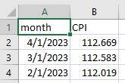
3. Last data of May 2023 is missing  
   data is imputed by calculating mean of previous 2 months CPI